Greece- A Celebration of Culture

with Alexandra Karacostas and Kathy Lane
April 26-May 10, 2024 (14nts)

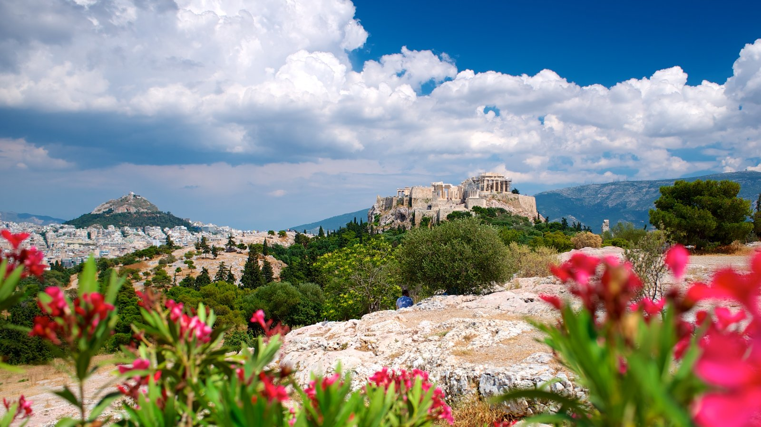

Blessings on our Journey!
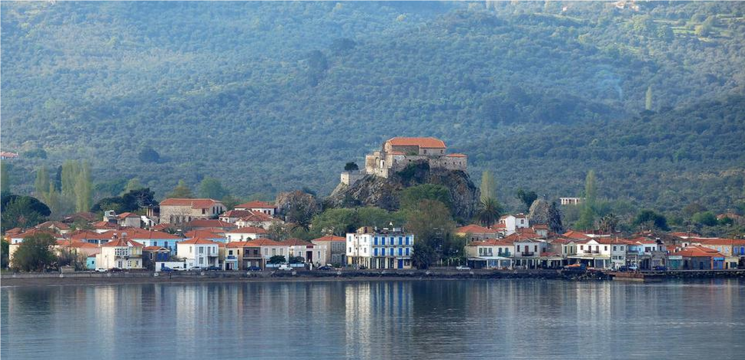
Our journey includes:
- Athens
- Sounion
- Delphi
- Island of Syros
- Island of Crete

Greece is a beautiful country with a rich heritage. She has an exquisite blend of age-old and modern architecture and culture evidenced almost everywhere you look. Athens itself offers a combination of first world contemporary lifestyle ammonites juxtaposed against remnants of a more forgotten way of life. It is a very mountainous country, almost 80%, but you are never too far away from the sea. Greece’s climate is diverse with high snowy peaks much of the year, perched above sandy beaches and blue water.

Be prepared for walking on uphill and downhill terrain. This tour is not recommended for those who are not able to be somewhat physically active. We will be sending out more information early next year about what you will need and what we suggest you bring along.
This journey’s theme revolves around Greek traditions and culture, ancient and modern, the history and myths of Greece and her people. We will be learning, visiting, sharing and celebrating.

Our route on land and sea….

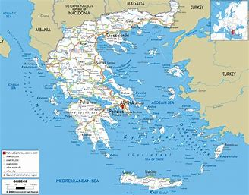

Athens
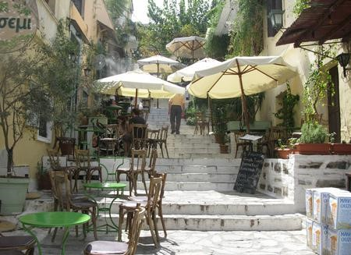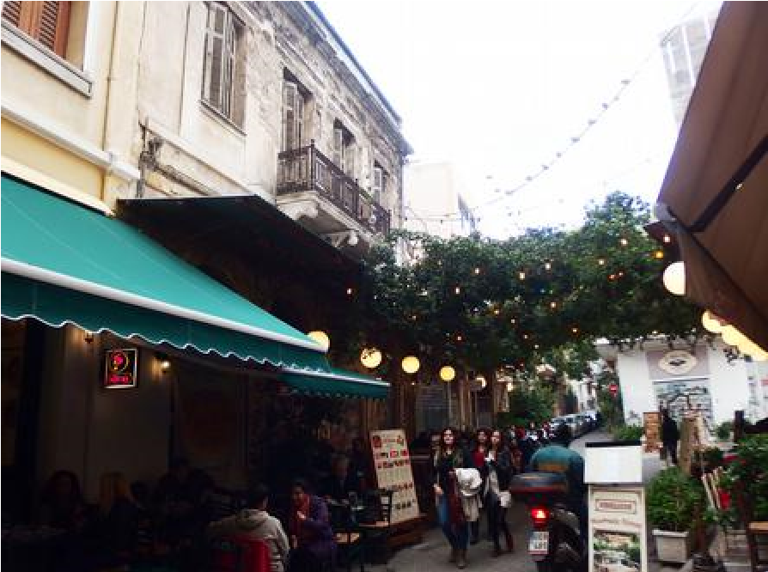
Welcome to Athens, the historical capital of Europe, and the birthplace of democracy, arts, science and philosophy of western civilization. Home of Plato, Socrates, Pericles, Euripides, Sophocles, Aeschylus. Athens is one of the world’s oldest cities. It’s recorded history spanning around 3,400 years and it is being inhabited since the 11th millennium B.C. E.

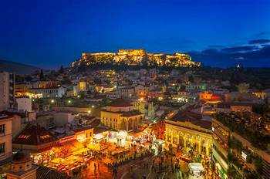

With the perfect Mediterranean climate and the legendary Greek sunlight, the unique combination of glorious history with modern, urban innovation, the coexistence of great culture with astonishing natural beauty, the high standard hotel accommodation, the vibrant rhythm of life, the wide choice of opportunities for shopping, dining and night life and of course the warmth of the Athenians people all contribute in making Athens as the ideal city destination. The city of Parthenon is an open-air museum.
A large part of the town’s historic center has been converted into a 3 km pedestrian zone, one of the largest in Europe. It leads to the major archaeological sites (“archaeological park”), reconstructing – to a large degree – the ancient landscape. Either on foot or by bike, the ‘’Grande Promenade’’ around Acropolis is an unforgettable journey through history.

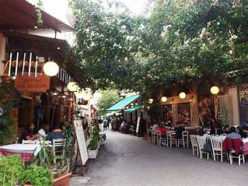

Acropolis, Athens
The Acropolis of Athens and its monuments are universal symbols of the classical spirit and civilization and form the greatest architectural and artistic complex bequeathed by Greek Antiquity to the world. In the second half of the fifth century BC Athens, following the victory against the Persians and the establishment of democracy, took a leading position amongst the other city-states of the ancient world. In the age that followed, as thought and art flourished, an exceptional group of artists put into effect the ambitious plans of Athenian statesman Pericles and, under the inspired guidance of the sculptor Pheidias, transformed the rocky hill into a unique monument of thought and the arts. The most important monuments were built during that time: the Parthenon, built by Ictnus, the Erechtheon, the Propylaea, the monumental entrance to the Acropolis, designed by Mnesicles and the small temple Athena Nike.

Friday – April 26 – Arrival in Athens- Royal Olympic Hotel (3 nts)

Welcome! We all gather at 6:00pm at the hotel lobby for introductions and a warm welcome. The evening is free to relax and prepare for our journey ahead, or to enjoy old Athens on your own exploring the Plaka and Psyri areas with their open-air markets selling everything from A to Z. This is a walker’s paradise.

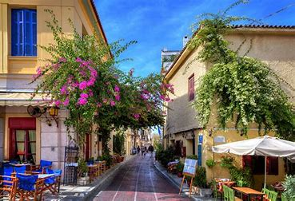
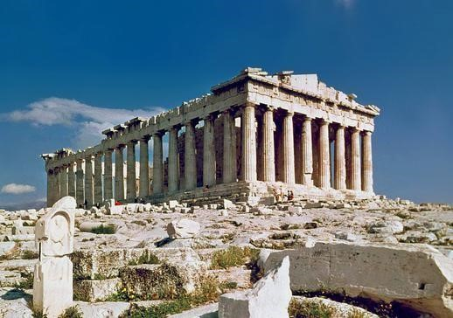

Saturday – April 27 – Athens

After breakfast we meet our guide for a guided tour to the Acropolis and visit to the Acropolis Museum. In the afternoon some of you may wish to walk or take a cab to the NationalArchaeological Museum, where fabulous treasures from ancient Greece are housed, including the Antikythera Mechanism, the oldest known computer, and the Santorini frescoes.

In the evening we will walk to Plaka for a traditional welcome Greek dinner at a local authentic Greek taverna beneath the spectacular Acropolis.

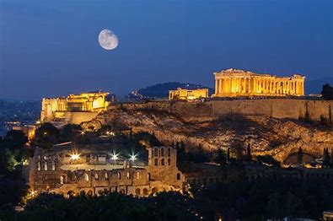

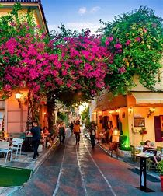

Sunday – April 28 – Athens and Sounion

This morning is free to explore Athens on our own. There are many museums nearby art galleries, tavernas, cafes, and shops to enjoy. In the afternoon, we board our bus for a visit down the Athens coastline to the temple of Poseidon in Sounion.
After our visit to the site, we will enjoy a seaside dinner and maybe a swim below the temple site.
The Ancient Greeks chose beautiful and intentional sites for their temples. Nowhere is this more evident than at Cape Sounion, 70km south of Athens, where the Temple of Poseidon stands on a craggy spur that plunges 65m down to the sea. Built in 444 BC – at the same time as the Parthenon – it is constructed of local marble.

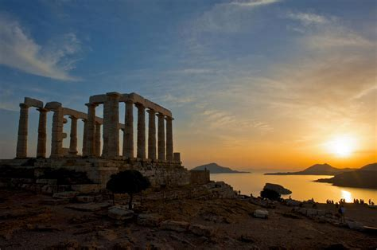

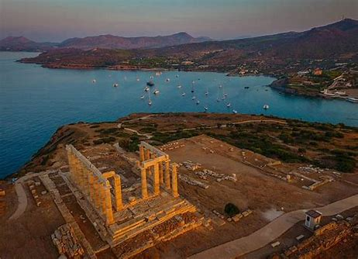

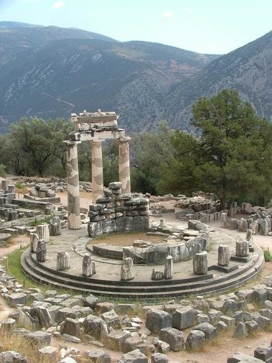
Monday- April 29 – Depart for Delphi Amalia Hotel (3nts)

After a leisurely breakfast, we prepare to leave Athens and drive to Delphi, the most famous center of divination in the ancient world by the foot of Mount Parnassus.
For over 1000 years, the serpent-wreathed Pythian priestesses go into trance and give prophecies to a host of pilgrims, including kings, generals, and philosophers who came to consult the Oracle.

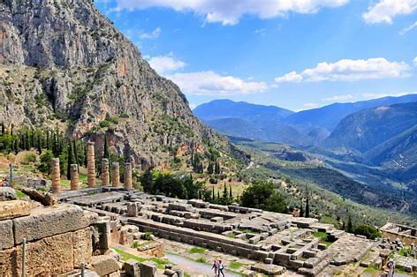

After check-in at our hotel, we are free to walk around the small, picturesque village of Delphi, shop or simply relax at the lovely hotel grounds.

Tuesday – April 30 – Delphi

In the morning, we go to the Delphi Museum and ancient Oracle site where we will be met by our guide.

In the afternoon, we will take a short drive through some of the oldest olive orchards in Greece to Galaxidi, a scenic seaside village. Here we will gather at the Ganamede restaurant for a Greek traditional cooking experience. We will make local dishes with the help of Chrisoula, our Greek chef, and then relish our own home cooked meal accompanied by Greek wine, dancing and local libations!

Galaxidi

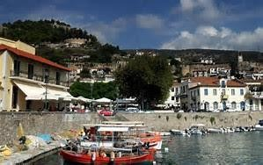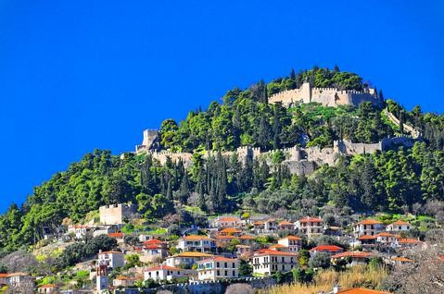

Wednesday – May 1– Delphi

The morning is free and we are on our own. In the early afternoon, we will go to the old and quaint village of Arahova for lunch. It is a mountainous village nestled at the foot of Mt. Parnassós and the most cosmopolitan winter ski destination for Athenians.

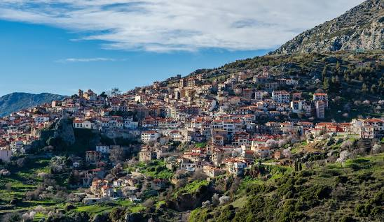

Thursday – May 2- Syros – Hermes Hotel (4nts)

After breakfast we board our bus for the afternoon ferry to Syros. After check-in at our hotel in Ermoupolis, we are free to explore this cosmopolitan and scenic island in the Cyclades.
Syros is the most populous island of the Cyclades, and in the past experienced impressive cultural and economic development. The capital and port, Ermoupolis, is a beautiful, stately city, unlike on any other Greek island.
Its neoclassical buildings, imposing mansions, and its vibrancy will charm you. Syros is also known for its beautiful beaches, traditional settlements, rich nature, local delicacies and a strong Catholic element, which gives it a special character.

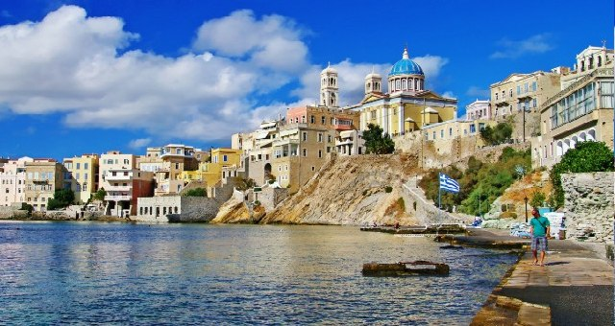

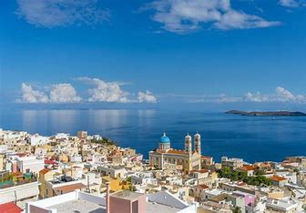

Friday – May 3- Good/Holy Friday
The morning will be free to explore Ermoupoli, with its delicious eateries and delightful sights.
Between 4pm-7pm, we enjoy a 3-hour guided tour visiting Ano Syros, the medieval settlement located up the hill in Ermoupoli. We will visit the Saint George Cathedral, the Catholic Monastery of Capuchins, and the church St. John built in 1635.
We will wander around the picturesque settlement with its small shops and the museum of Markos Vamvarakis, one of the most influential Greek rebetiko music composers. Rebetiko is music composed during the Greek resistance movement and is filled with passion and musical harmonies.
We continue our journey to the village of Episkopio in the center of the island, where we visit the chapel of Prophet Elias to attend the service of the entombment and burial procession of Jesus Christ.
During this service, the body of Christ is removed from the cross and the priest wraps the body in a sheet and carries it on his back three times around the church. He then places it on the Epitaphio which is then carried by the faithful along the streets of the village chanting hymns.

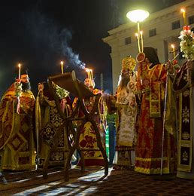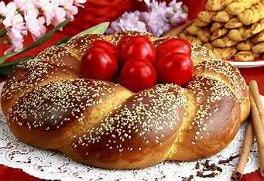

Saturday – May 4- Holy Saturday
We begin our day with a two-hour private tour. Our first stop is the church of Agios Nikolaos/St Nikolas, the patron saint of Ermoupoli, that stands out with its lavish interiors and impressive architectural structure.
We see the sights of the district of Vaporia, featuring mansions hovering over above the sea, visit the Apollon Theater, a major attraction and cultural icon of the city. Built in 1864 and designed by the Italian architect Pietro Sampo, who drew inspiration from Italian standards, including the Scala di Milano. The theater today hosts various cultural events.
We make our way to the heart of Ermoupoli and Miaoulis Square, Syros’s historic plaza, a beautiful landscape of the 19th century. There is much more to see and learn as we continue our journey through this elegant town.
Sunday – May 5 – Easter Sunday
Today we celebrate Greek Easter on Syros. Our tour begins at 8:30 and ends at 4:00pm. At the village of Chroussa, the owner of a neoclassical mansion will welcome us to her home for a traditional Greek meal in her yard. We will see how kokoretsi is cooked on the spit, how traditional pies, and taste an assortment of Greek flavors are made by the locals and grown organically nearby. We will learn about the traditions, rich history and culture of the island, and gain insight into the meaning of Greek Pascha, as we celebrate the special holiday of Easter with the locals.
Monday – May 6- travel to Crete – Hotel Nema (4nts)
Today we travel by ferry from Syros to Heraklion, Crete. We settle into our seaside hotel and the evening is our own to relax, swim or walk around town.

Crete is the largest island in Greece, and the fifth largest one in the Mediterranean Sea. Here, you can admire the remnants of brilliant civilizations, explore glorious beaches, impressive mountains capes, fertile valleys and steep gorges, and become part of the island’s rich gastronomic culture. Crete is, after all, a small universe teeming with beauties and treasures, and its own unique culture that you will probably need a lifetime to discover.

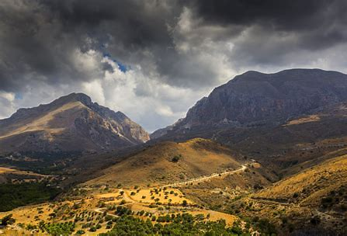

Crete is renowned for its pin-up beaches, wild natural beauty, exquisite cuisine and thousands of years of culture and history. As Crete’s most celebrated author, Nikos Kazantzakis (of Zorba the Greek fame), once wrote: “The mystery of Crete runs deep. Whoever sets foot on this island senses a mysterious force coursing warmly and beneficently through their veins, sensing their soul beginning to grow.”

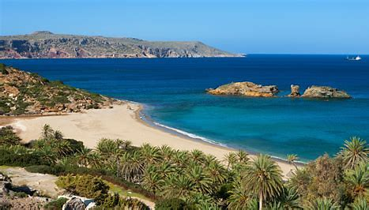

Tuesday – May 7 – Heraklion – Knossos Palace and Olive tour
We spend the afternoon visiting Knossos Palace and Cretan Mill Olive Estate. This a 5-hour tour with our expert guide throughout the great kingdom of Minos and then on to learning the secreta of the renowned Cretan olive production. From Knossos we travel up the gentle rolling hills outside of Heraklion to the family estate of the Mill where we go olive oil tasting.

Knossos - What makes Knossos so impressive to historians is that it was not simply a residence for a royal family – it was also a center of government, commerce, and culture. The palace was home to many workshops where craftsmen produced goods for trade with other parts of the Mediterranean. It is also home to one of the last remaining archaeological palaces which was built around a mother-goddess worshipping hierarchy of spirituality. And thanks to its location near the coast, Knossos also served as an important port city. All this combined makes Knossos one of the most significant archaeological sites in Europe.
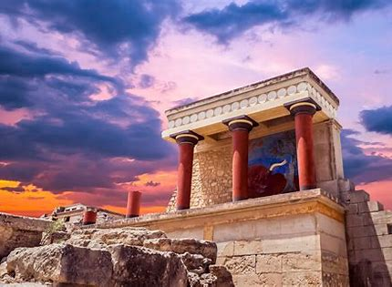
Wednesday - May 8- Elounda-Spinalonga-BBQ at Kolokitha- Agios Nikolaos
This excursion is a trip back in time since it carries with it a feel of another era. Our excursion begins at the beautiful harbor of Elounda where we board our boat to visit the small sland of Spinalonga, about 1 ½ hours away. It has a rich and often tragic history, which our guide will share with us. Afterwards, we will depart for one of the pretty bays for some swimming in the crystal clear waters, and savor our BBQ on board before going to Lassithi, Agios Nikolaos. We relax at a café, and enjoy a stroll around the small shops before returning to Heraklion.
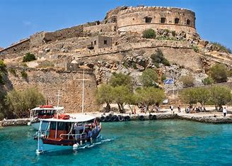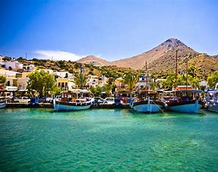
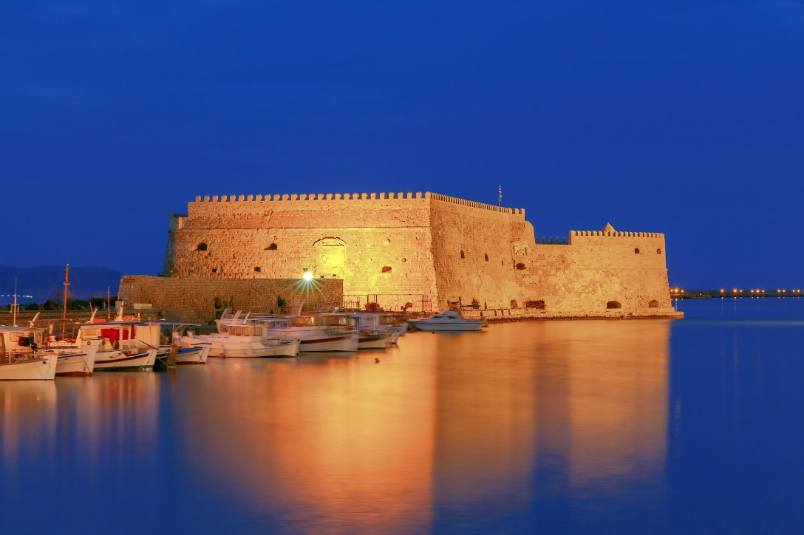
Thursday – May 9 –Heraklion
Today is free to adventure around Heraklion on its coblle streets, shop, eat and go to the outstanding Archeological Museium nearby, definetely a place worth visiting!
In the evening we gather to share a lovely meal at Perasties, one of Herakion’s finest restaurants as we celebrate our time together on this special journey.
Friday – May 10 - Transfers to the airport, or port, for departures home, or to your next destination.
Pame, (let’s go) Greece
Blessings on our journey!
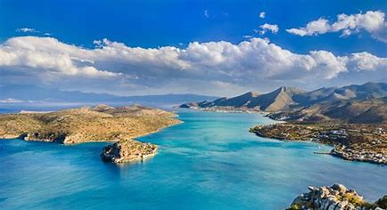

Pricing
This tour is limited participation

Rates are per person based on Double Occupancy and are 5195 Euro per person and single supplement is 1050 Euro. Please note that all rates are in Euro.
We require a 1000.00 Euro per person non-refundable deposit to hold your space.
***Early Bird special of 4995 Euro if paid by October 15, 2023***
Travel insurance is strongly recommended!
Registration Applications and Waivers need to be signed and returned to us. We will send them to you as soon as you sign up.

Rates include:
- Accommodations – All properties are 4 or 5 stars (except on Syros- 3 ½ star)
- 3 nights - Athens
- 3 nights - Delphi
- 4 nights - Syros
- 4 nights - Crete
- Deluxe a/c motor coach in Athens, Sounion, and Delphi, and to the airport for our flights
- Transportation to Syros and Crete
- Deluxe a/c motor coach on Crete
- Excellent English and qualified guides for: Athens Sightseeing, Cape Sounion, Delphi, Syros, Knossos, The Mill, Elounda and Spinalonga
- Entrance fees to Acropolis, Sounion, Delphi, Knossos
- Daily breakfast
- Athens Acropolis site and museum tour
- Dinner in the Plaka under the Acropolis
- Seaside Dinner at Cape Sounion
- Mezes dinner which we learn to cook, accompanied by local libations and dancing in Galaxidi
- Delphi Oracle site and museum tour
- Easter Lunch
- BBQ dinner in Crete
- Dinner last night in Heraklion
- All road tolls & taxes
- Tips for guides and drivers
- And more…..
Rates do not include:
- Travel Insurance – STRONGLY ADVISED
- Arrival transfer in Athens (can be arranged for additional cost)
- Any drinks during meals which are not included
- Any personal expenses
- Anything not clearly mentioned above as included
- For assistance with inter-island travel before or after tour, or other travel needs, please contact our outstanding travel agent and right hand in Greece, Irene Komatseli at irene@travelsmart.gr.

Contact Information

Alexandra is a Greek-American who lives and works both in Greece and in northern California. She has traveled extensively throughout the world over the decades, and has lived in various areas of both Greece and the U.S. With over 30 years in the travel industry, Alexandra now enjoys leading small, specialized tours to her beloved homeland, sharing its immense beauty, ancient sites and traditional culture. Alexandra is professional astrologer, teacher, writer and workshop facilitator serving an international clientele. Visit her website: wwwWisdomAstrology.com
Alexandra Karacostas, (530) 520-9992 | alexandrakaracostas@yahoo.com

Kathy Lane has extensive experience in the travel industry as an advisor, travel store partner, and Butte Community College travel and tourism instructor. She currently works with an agency as a full-service consultant for domestic and international itinerary planning. She has visited many destinations throughout the U.S. and abroad, and recently visited Greece this past September with longings to return.
Kathy Lane. (530) 514-6939 kathylaneexp@yahoo.com

